Data Analytics (DA)

Module-End -2 Assignment:

“Data Transformation, Modeling & Visualization with Power BI”

Title: Analyzing Smart City Bike Sharing Data using Power BI
Data Sources:
Source: Dataset link
Problem Statement:
Public bike-sharing systems generate continuous data from hundreds of stations across different cities. The task is to analyze this real-time bike station dataset to understand station performance, usage efficiency, and operational patterns across cities.
Applying Power BI skills—from data cleaning and modeling to DAX and dashboarding—to turn raw data into actionable urban mobility insights.
Attribute Details:
Attribute Name | Data Type | Description
Number | Integer | Unique identifier for each bike station
Name | Text | Name of the bike station
Address | Text | Physical address of the bike station
Position | Text | Geographic coordinates (latitude and longitude) of the station
Banking | Boolean | Indicates whether the station supports card payment (TRUE/FALSE)
Bonus | Boolean | Indicates whether the station offers bonus features or incentives
Status | Text | Operational status of the station (OPEN / CLOSED)
Contract Name | Text | Name of the city or contract under which the station operates
Bike Stands | Integer | Total number of bike stands available at the station
Available-Bike Stands | Integer | Number of empty bike stands currently available
Available Bikes | Integer | Number of bikes currently available at the station
Last Update | DateTime (Text) | Timestamp of the most recent data update

- Import and explore the dataset in Power BI.
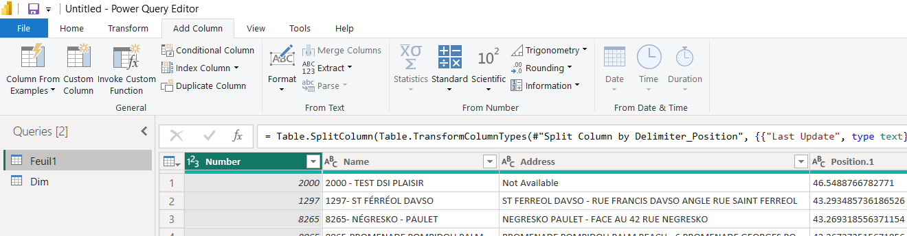

- Clean and transform data using Power Query.
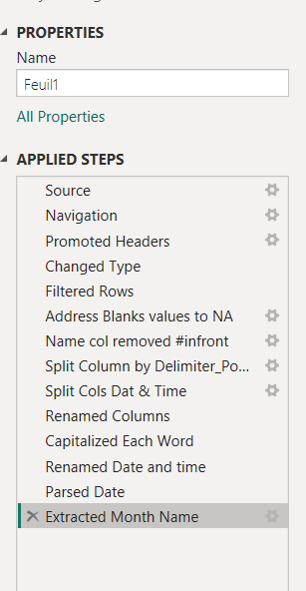

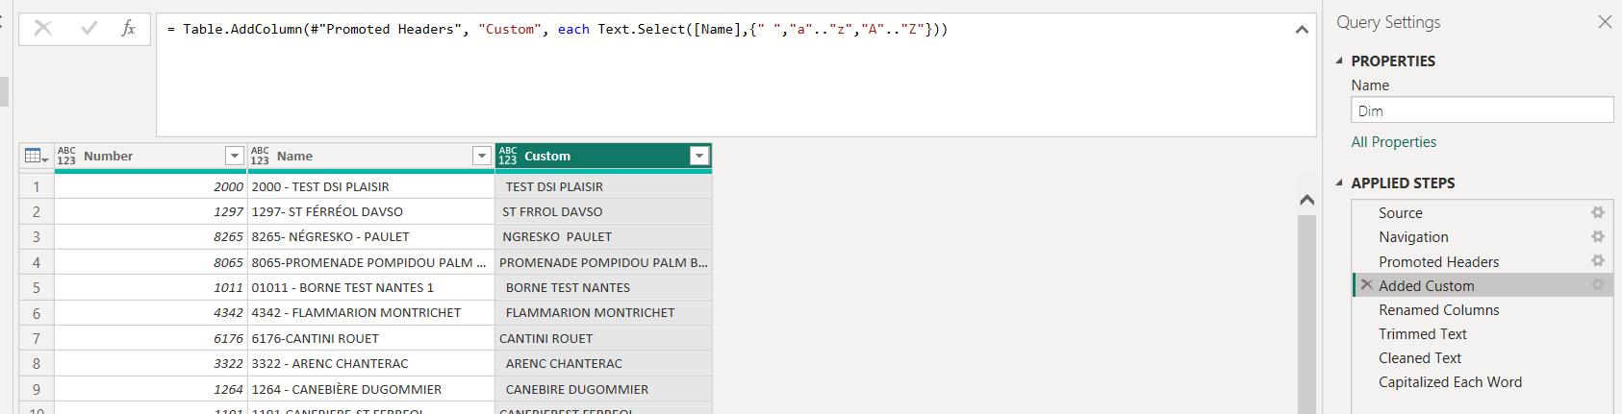

- Build a logical data model.
  - Set up a fact table.
  - Create dimension tables and
  - Defining the relationships between the fact and dimension tables
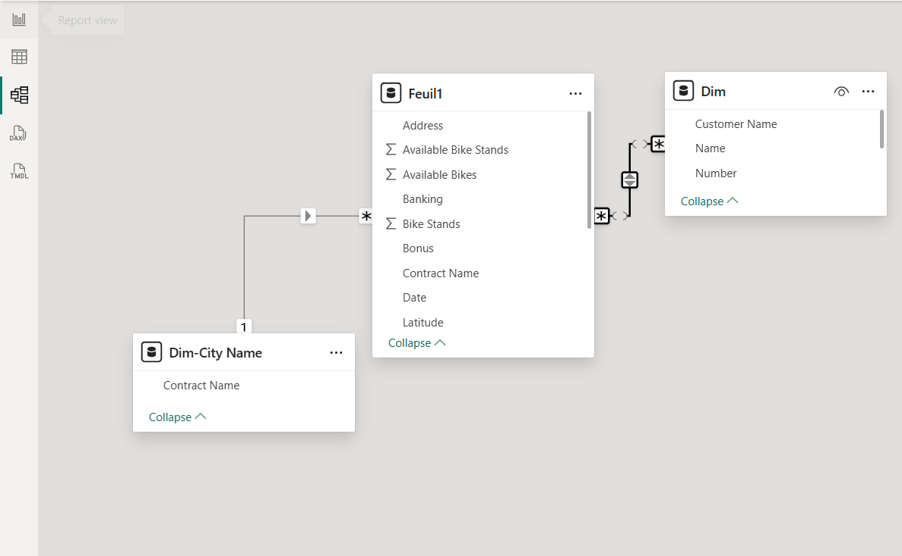

- Create DAX measures and calculated columns (wherever needed).

Station Availability Status = If(Feuil1[Available Bikes]=0,"Empty",IF(Feuil1[Available Bike Stands]=0,"Full","Available"))

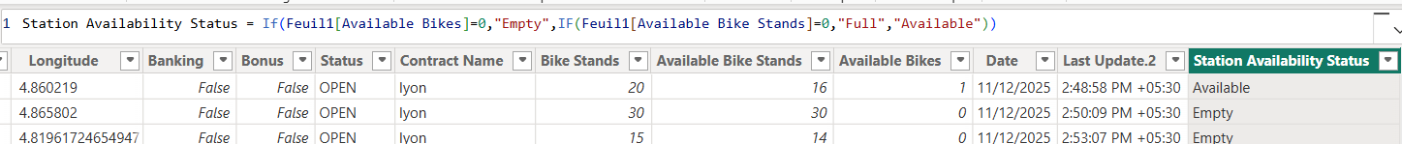

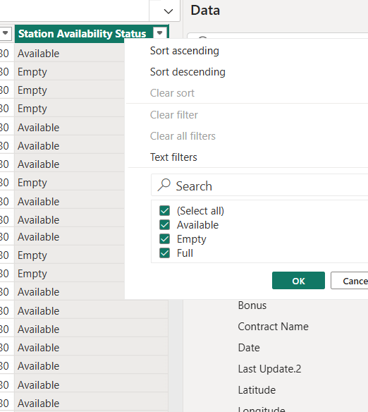

Utilization %_per station = DIVIDE(Feuil1[Available Bikes],Feuil1[Available Bike Stands],0)

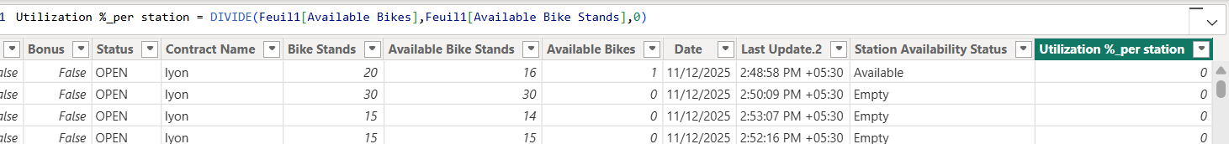

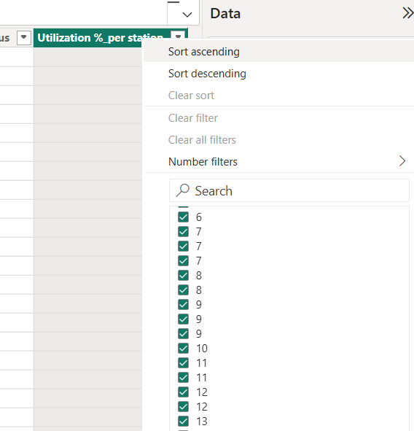

Status-Wise Station Table = SUMMARIZE(Feuil1,Feuil1[Status],"Station Count",COUNT(Feuil1[Number]),"Total Bikes",SUM(Feuil1[Available Bikes]))

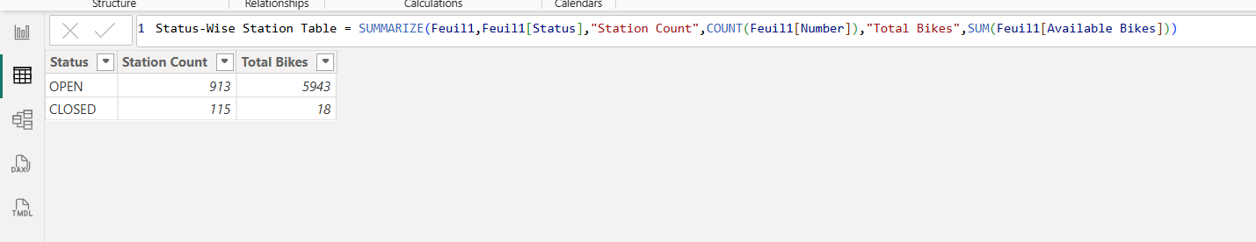

- Design interactive visuals and dashboards.

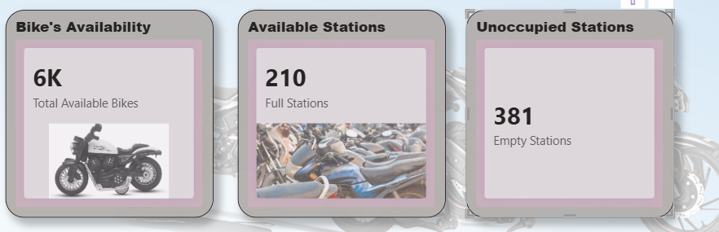
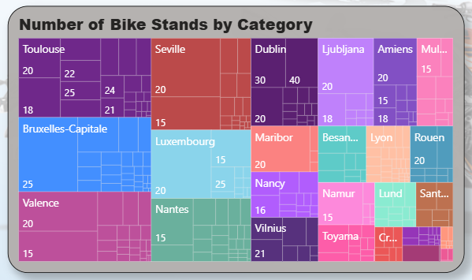

Question Analysis:

- How does station availability status (Available / Empty / Full) vary across cities?
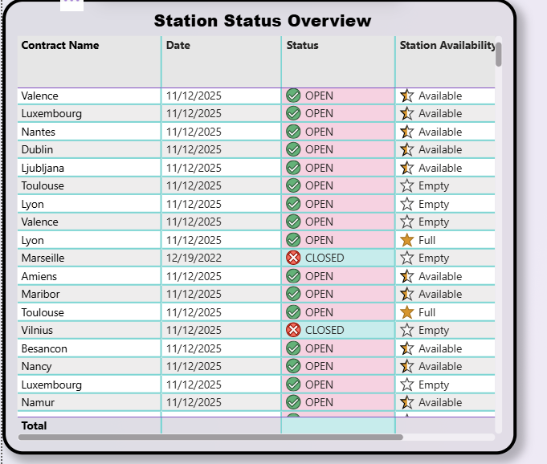

- How is bike availability distributed across all stations?

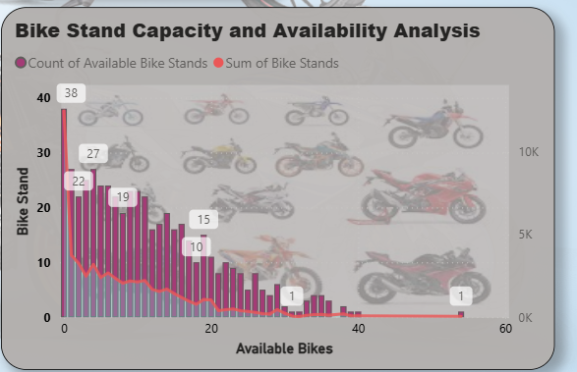

- On which month does bike availability peak or spike significantly?

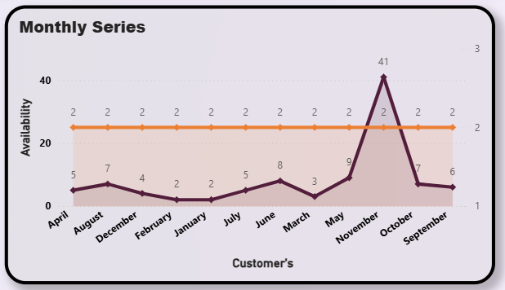

- What is the average utilization rate per station?
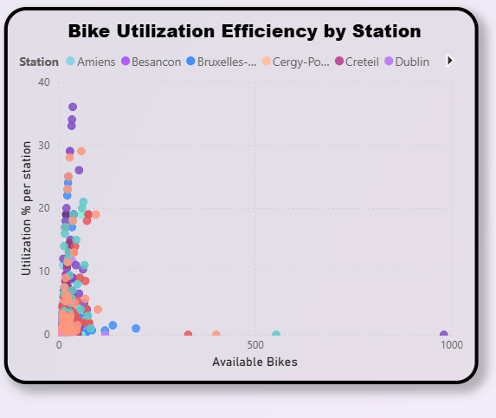

- How does the balance between increases and decreases vary by station?

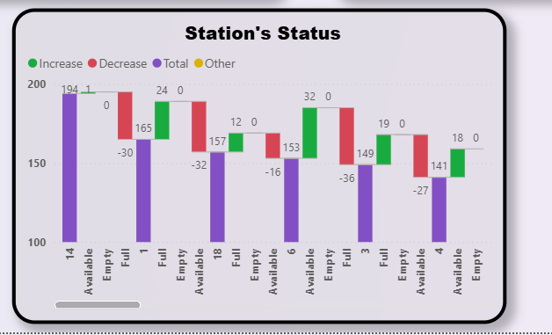

Dashboard Overview:

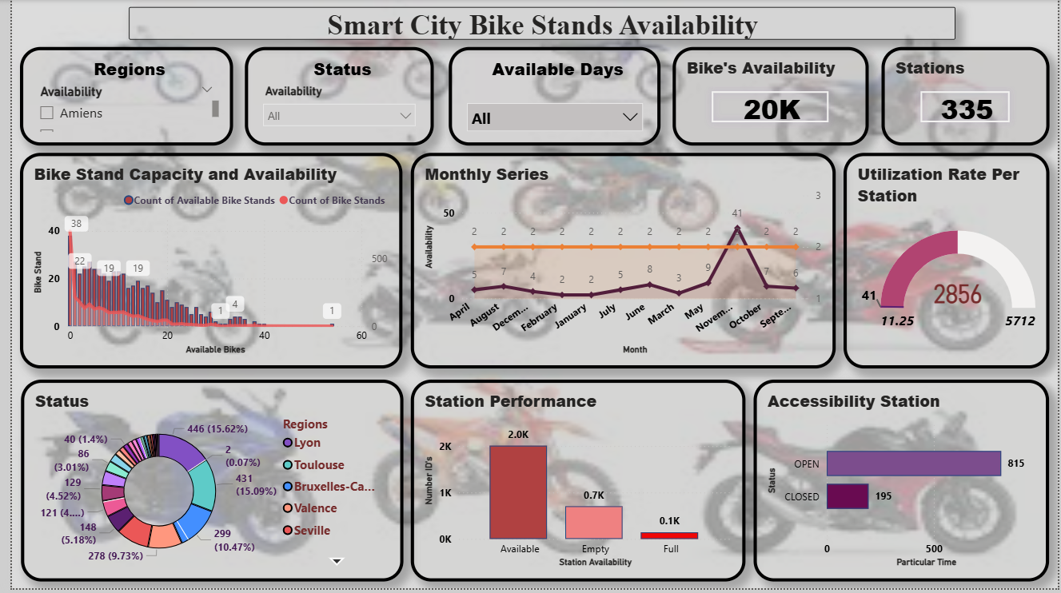

Dashboard Analysis:

- Top dates by total available bikes-11/12/2025
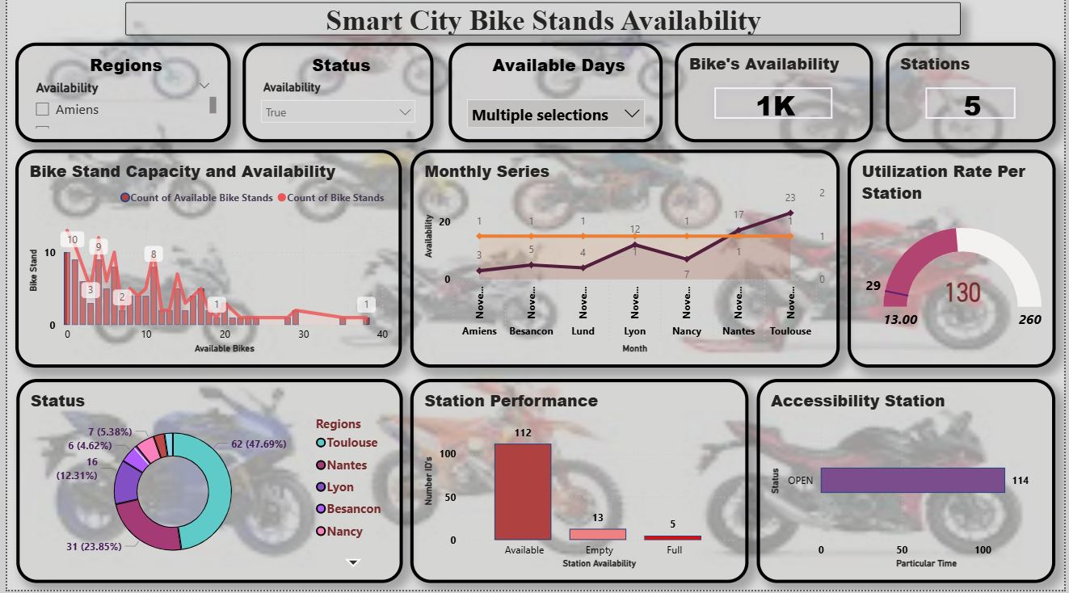

- Station Performance Status: A higher count of available bikes compared to full stations suggests supply exists, but not always where demand is highest.

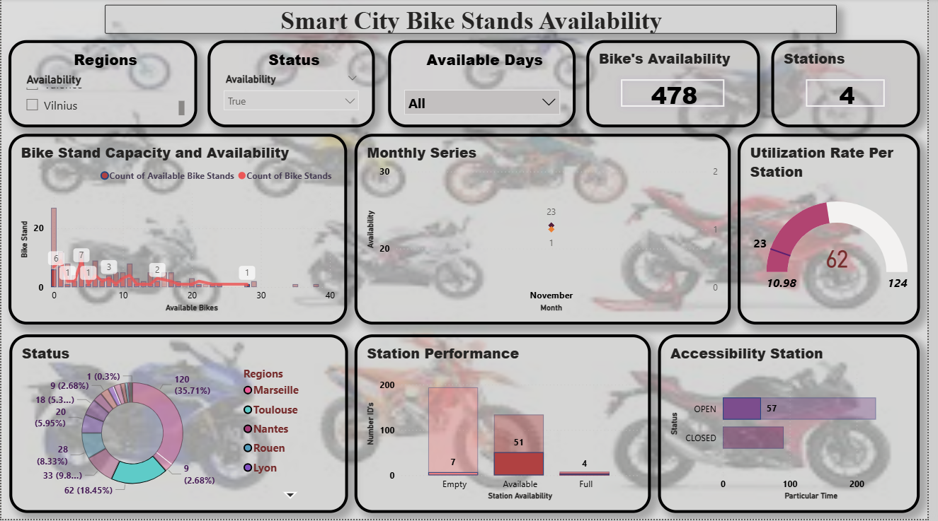

Report Summary:

- Overall Availability: The system shows moderate bike availability (~20K bikes), but distribution is uneven across stations, indicating localized shortages and surpluses.

- Utilization Rate Insights: Stations show uneven utilization, with some being heavily used and others underused—pointing to optimization potential in station placement and bike redistribution.

- Time-Based Fluctuations: Bike availability varies significantly across time and customer usage patterns, suggesting strong peak-hour demand and underutilization during off-peak periods.

This report analyzes smart city bike-sharing station data to evaluate station performance, bike availability, usage, and operational efficiency across cities. Using Power BI, raw station data was transformed into interactive dashboards highlighting high-demand and underutilized stations. These insights support better bike redistribution, infrastructure planning, and improved mobility services.

Conclusion:

The bike-sharing system has adequate overall availability, but bikes are not evenly distributed across stations. Usage varies by time and region, leading to peak-hour shortages and off-peak underuse. Some stations are highly utilized while others remain underutilized, indicating imbalance. Regional performance differences highlight areas needing focused improvement. Better rebalancing and demand planning can improve efficiency and user satisfaction.

